Electron structure calculations of metal isotope signatures in combustion products

Supervisors: Professor Dominik Weiss, Nina Schleicher

Chushan Peng

Jan 2021

This report is submitted as part requirement for the MSci Degree in Geophysics at Imperial College London. It is substantially the result of my own work except where explicitly indicated in the text.

The report may be freely copied and distributed provided the source is explicitly acknowledged.

The main body of this dissertation has 4527 words

Table of Content

Abstract 4

1. Introduction 5

2. Background 5

3. Methodology 6

**3.1** DFT methods 6

**3.2** Molecules choices and their structures 7

**3.3** Reduced partition function ratio calculation 8

**3.4** Selection of isomers 9

**3.5** Isotope fractionation calculation 9

4. Result and Discussion 10

**4.1**. Accuracy of the electron structure calculation method 10

**4.2** The effect of isomers on isotope fractionation 12

**4.3.** Isotope signature calculation and environmental applications 17

4.3.1 Model for stable isotope fractionation of Zinc 17

4.3.2 The isotope signature of ZnCl2 and ZnSO4 in combustion product 18

4.3.3 The effect of isomers on isotope signature calculations 20

5. Conclusion and future study 21

6. References 22

7. Appendix 25

Appendix A 25

Appendix B 27

# Abstract

In this study, electron structure calculations have been performed to determine the reduced partition function ratio of Zinc species that are relevant to coal and waster combustion. The level of theory used is B3LYP and the results have shown great consistency with past studies

In addition, this study also assessed effect of structural isomers of the ZnSO4 species. Different structural isomers have shown significant differences in their reduced partition function ratio (β). No link have been found between the β value and the energy of the isomers or the bond length between central Zn atom and the SO4 ligand. However, using different structural isomers does not seem to have the same magnitude of effect and fail to use the energetically most stable isomer is not expected to invalidate the isotope signature calculated. Nevertheless, using the most stable isomer or a combination of different isomers is expected to increase the accuracy of the result, and is therefore always recommended.

A simple model of the reaction of Zn species during condensation after coal or waste combustion has been created. ZnCl2 and ZnSO4 are the dominant species and the dominant reaction is ZnCl2(g) + SO2 +1/2O2 +H2O-> H2O+ZnSO4(s) + 2HCl. ZnSO4 has a heavier isotope signature than ZnCl2 and a fly ash sample with a heavier isotope signature is expected to contain more ZnSO4 species. For a coal sample with an isotope signature of δ66ZnIRMM = +1‰, δ66Zn is expected to be between +1‰ and + 1.04‰ for ZnSO4 and between +0.81‰ and +0.85‰ for ZnCl2.

This model creates a good starting point for isotope signature calculation for combustion products and is useful is predicting the isotope signature of the metals relating to a pollution source.

# Introduction

Heavy metal pollution has been causing increasing concerns due to its high toxicity to human body and the environment. They can accumulate inside the human body through the atmosphere or through vegetable or meat consumption, which can cause organ damage and cancer even at low level of exposure (Tochounwou et al 2013; Briffa, Sinagra and Blundell, 2020). Zinc is a heavy metal that can be emitted during industrial processes in large quantities via multiple pathways and accumulate in the environment (Qu et al. 2012; Wang et al. 2005). Tracing and identifying the source of such trace metals is an important step towards cutting down pollution. Isotope signature calculation has been one of the main methods for tracing a pollution source, as heavy metal from an anthropogenic will show a distinct difference in its isotope signature comparing to nature sources, as well as between different anthropogenic sources.

In this study, DFT model chemistry will be used to calculate electron structure of ZnCl2, ZnSO4 hydrates and Zn(H2O)6, which will then be used to model the isotope fractionation caused by vibration of the molecules. While collection of field data on isotope signature of heavy metals is practically impossible due to the extremely high temperature inside a furnace, computational method can allow an estimation on the isotope signatures of each Zinc species after combustion which allows us to trace back to the source of a field sample. The ability the isotope signature of different Zinc species separately is also unique to computational modelling, the isotope signature information of multiple species makes it possible to predict the trend in the variation of the total isotope signature of a fuel gas at different distances away from the original source.

Structural isomers for the Zn species will also be established, electron structure and energy calculation for the isomers will be carried out on order to assess the effect of their existences on the isotope signature of Zn species.

# Background

During an equilibrium reaction, the vibrational energy plays a key role in controlling the fractionation between different phases. The reduced partition function ratio, β, which measures the equilibrium isotope fractionation between two species, can be calculated by comparing the vibrational energy of the two species (Schauble et al., 2017; Hunt Research Group, Imperial College London, 2021).

Variation in isotope composition is commonly expressed using the δ notation which means ‘per mil deviations from a giving isotope standard’. δ66Zn is defined as:

The two common standard references used for Zn isotope signature measurements are ‘JMC Lyon’ and ‘IRMM’ (Maréchal et al., 1999; Moeller et al., 2012). δ66Zn in this study refers to δ66ZnIRMM unless stated otherwise.

The isotope fractionation, Δ, is the differences in isotope composition between two species.

Diaz-Somoano and Martinez-Tarazona (2002) used thermodynamic equilibrium calculation to determine the trace element behaviour during coal gasification. They concluded that with the presence of HCl, the formation of ZnCl2(g) is favoured between 300-1000 degrees during combustion. Cai et al. (2014) used XANES and EXAFS spectroscopy to analyse the Zn composition in fly ash particles. ZnCl2 was found to be the most common species in the grate system and at high Sulphur concentration, the ZnCl2 can be impeded and condense into ZnSO4.

Black et al. (2015) determined the reduced partition function ratio for a large variety of Zinc species, including Zinc aqua, Zinc Sulphite hydrates and Zinc Citrates. The study confirmed the existence of chemical fractionations between different Zinc species and predicted distinct Zinc isotope signature in places with industrial pollution. However, Black has made no attempt to account for the effect of structural isomers on the reduced partition function ratio of the species, which can cause potential inaccuracy in the result. The effect of structural isomers will be further assessed in this study.

# Methodology

## **3.1** DFT methods

In this study, the geometry of the molecules are optimised using the density functional theory (DFT) through using the software Gaussian 16. Vibrational frequencies of each molecule are then calculated from the optimised structure using the same parameters. The level of theory is B3LYp and the basis sets used are 6-31G* for non-metals (O, H, Cl and S) and LANL2DZ for Zn. All optimizations were done with a ‘tight’ level of tolerance and an integration grid of ‘ultrafine’. Some molecules were calculated with specific enforced point group symmetry, which are stated on table 1.

## **3.2** Molecules choices and their structures

The first set of reduced partition function ratio calculations are based on the calculations done by Black et al. in 2010. Five of Black’s structures were taken to be used as the initial molecule structures for this study- Zinc hydrates: Zn01 and Zn02, Zinc Sulphites: ZnIS01 and ZnIS04, and Zinc Chloride: ZnCl01. ZnIS01 and ZnIS04 have the same geometry but different number of molecules, this allows the effect of the size of the molecule on the resultant partition function to be assessed. The optimisation result of these structures will then be compared with Black’s result. In addition, ZnCl2(g) molecule is also used in this study. During coal combustion at high temperature, ZnCl2(g) and Zn(g) are the most commonly formed Zn species (Cai et al. 2014). Zn(g) has no vibrational fractionation, therefore, only ZnCl2(g) is considered out of the combustion products at high temperature. ZnCl2(g) is a linear molecule at gas phase, with a bond length of 2.05 (Hargittai, 1988). Previous studies has identified three common ZnCl2 complexes in aqueous solution (Hennings, Schmidt and Voigt, 2014). These molecules will not be included in this study as ZnCl2(g) mainly exists when the temperature is > 800⁰C, the high temperature means that it is unlikely that the molecule is bonded with water molecules, however, it is worth noticing that different complexes can have different reduced partition function ratio and cause potential inaccuracy in the modelled isotope fractionation values. A summary of the molecules, their code, geometry, and symmetry are shown on table 1.

Table 1 A list of molecules calculated, their chemical formula, code, geometry, and symmetry

|  |  |  |  |  |
| --- | --- | --- | --- | --- |
| **Molecule formula** | **Molecule code** | **Black's code** | **Symmetry** | **Geometry** |
| ZnSO4·4H2O | ZnSO4_inner1_A | ZnIS01 | C2 | Octahedral |
| ZnSO4·7H2O | ZnSO4_inner2 | ZNIS04 | - | Octahedral |
| [Zn(H2O)6]2+ | ZnH2O_A | Zn02 | Th | Octahedral |
| [Zn(H2O)6]2+ | ZnH2O_B | Zn01 | - | Octahedral |
| ZnCl2 | ZnCl2 | - | - | Tetrahedral |
| [ZnCl4]2- | ZnCl4 | ZnCl01 | Th | Tetrahedral |

Other Zinc species such as ZnAl2O4 and Zinc Silicates are also relatively common (Querol et al., 1994; Cai et al, 2014), however, they are beyond the scope of this project and will not be included in the electron structure calculations or the combustion model of this study.

H2SO4 and HCl molecules have also been optimized using the same level of theory and basis sets to ensure consistency in the energy calculation of the reaction. The geometry information of these molecules are taken from the Computational Chemistry Comparison and Benchmark Database (CCCBDB listing of experimental data, 2020)

## **3.3** Reduced partition function ratio calculation

The reduced partition function ratio of each molecules are calculated using only the vibrational frequencies of each molecule, through the equilibrium fractionation theory proposed by Schauble (2017).

(eq.1)

Where is commonly referred as the reduced partition function ratio of a molecule, h is the plank constant (6.6261 x 10-34 Js), k is the Boltzmann constant (1.3806 x 10-23 J/K), T is the temperature in Kelvin, v and v’ are the frequencies of the heavy and light isotope respectively and N is the number of atoms within the molecule.

Equation 1 can be rearranged into the following equations

(eq.2)

Where

(eq.3)

c is the speed of light in unit of cm/s. The speed of light is included in this equation to conserve the unit for frequency from gaussian output from cm-1 to Hz.

A python program with equation 2 and 3 implanted has been produced which reads in the frequency data from gaussian output and calculates the reduced partition function ratio at any given temperature. The python code can be found in the supplementary material.

## **3.4** Selection of isomers

Black et al. only proposed only one single geometry for the structure ZnSO4·4H2O, however, it is possible that energetically more stable isomer exists, which can potentially lead to inaccurate reduced partition function ratio calculation. This study will establish structural isomers for ZnSO4·4H2O and carry out Gaussian calculation of each isomer. The total number of atoms is kept the same for all the isomers in order to keep the same formula and eliminate any potential differences in molecule vibrations caused by having different number of atoms. Zinc2+ can form both octahedral and tetrahedral structures, producing seven possible isomers of ZnSO4 that will be used in this study. Isomer A and B have octahedral geometries and are the same structure with and without forced point group symmetry, Isomer C-G have tetrahedral geometry, with two water ligands positioned at different location of the structure. The 2D structural information of each isomers are provided in appendix A.

An isomer is considered unique if its optimized structure has an energy difference of > 5kJ. Structures with an energy difference of < 5kJ will be visually assessed and decided whether it is unique case by case. The reduced partition function ratio of all unique isomers will be calculated, cross compared, and compared with Black et al.’s result. This will allow the effect of using different isomers during reduced partition function ratio calculation to be quantified.

## **3.5** Isotope fractionation calculation

The relative magnitude of isotopic fractionation, Δ, between two species can be defined as:

(eq.4)

Where are the reduced partition function ratio of the two species, i.e., ZnCl2 and ZnSO4 respectively in this study. A and B stand for the first and second species of interest.

During combustion, ZnCl2(g) preferentially forms if Chlorine is present. After being emitted into the atmosphere, it can then react with other atmospheric substances to form other Zinc species such as ZnO at high temperature and ZnSO4 at low temperature (Verhulst et al., 1995). Coal has a particularly high Sulphur concentration, which can lead to highly concentrated ZnSO4 content (Cai et al. 2014). Other common Zinc species are ZnAl2O4 and Zinc carbonate and silicate.

The mass balance between ZnCl2 and ZnSO4 can be expressed as:

(eq.5)

Where is the total isotopic signature of Zn at 100% combustion, and are the isotopic signature of the ZnCl2 and ZnSO4 species in a sample, and is the fraction of each species in the sample which sums up to 1.

Combining eq.4 and 5, we can express the isotopic signature of ZnSO4 () of a sample, for any mixing ratio of the two species as:

(eq.6)

(eq.7)

The reduced partition function ratio of different Zinc species varies differently with change in temperature, therefore varies as a function of temperature and its fraction in the total Zinc species. This allows us to trace back to the source of the aerosol through curve fitting.

# Result and Discussion

## **4.1**. Accuracy of the electron structure calculation method

Table 2 shows the calculation result of the reduced partition function ratio ( for Zn/Zn at 0-300⁰C for different Zn species of this study and Black’s study. Figure 1a-d plot the reduced partition function ratios value from this study and Black’s study for ZnSO4_inner1_A, ZnSO4_inner2, ZnH2O and ZnCl4, respectively. The result from Black’s study and this study have shown extreme consistency. For ZnSO4_inner2, ZnH2O_A, ZnH2O_B and ZnCl4, the figures show an almost perfect overlap, with the maximum differences in the reduced partition function ratio between the two studies being -0.02 comparing to the previous study.

The ZnSO4_inner1 molecule has shown a larger difference comparing to other molecules, with a maximum difference of -0.19 at 0⁰C, and an average difference of -0.1, comparing to Black’s study. The promising result from the reduced partition function ratio calculation of other molecules means that it is safe to assume that this inconsistence is not caused by errors in the molecule production or calculation process of this study and our method is still overall valid and accurate.

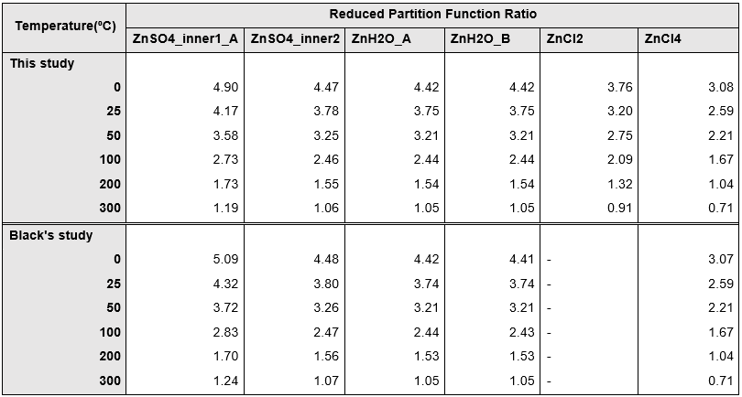

Table Reduced Partition Function calculation result at 0-300 ⁰C. Corrected to 2 decimal places.

ZnSO4_inner1_A is a well converged stable structure, with the RMS of its geometry convergence being 7x10-6 and the RMS of its energy being 0 (correcting to 6 decimal places). Furthermore, as shown on figure 1a, the largest disagreement in value exists at the lowest temperature end, in this study, the reaction we will consider in later sections happens mostly at >800 K (>500⁰C), the small inconstancy at low temperature will only have minimal effects on the isotope fractionation calculation in later sections.

It is therefore safe to assume that all the structures optimized in this section have provided accurate reduced partition function ratio to be used in later sections of this paper.

## **4.2** The effect of isomers on isotope fractionation

A total of seven structural isomers have been identified for ZnSO4·4H2O, labelled A-G. Isomer A is the original structure that was calculated and optimized in section 5.1, isomer B is the identical structure without constrains on point group symmetry during optimization. Isomer C-G are tetrahedral ZnSO4·2H2O structures with unbonded water molecules.

|  |  |  |  |  |
| --- | --- | --- | --- | --- |
| **Isomer** | **∆E (kJmol-1)** | **1000lnβ at 200K** | **1000lnβ at 1200K** | **Unique isomer?** |
| **A** | 0 | 8.64 | 0.28 | Y |
| **B** | 1.58x10-4 | 6.81 | 0.21 | N |
| **C** | 1.37 | 8.49 | 0.25 | Y |
| **D** | -19.36 | 9.84 | 0.32 | Y |
| **E** | -5.82 | 9.37 | 0.29 | Y |
| **F** | 69.16 | 9.10 | 0.29 | Y |
| **G** | 94.82 | 9.16 | 0.30 | Y |

Table 3 shows a list of the ZnSO4·4H2O isomers, their relative energy, reduced partition function ratio at room temperature and whether they are identified as a new isomer. Isomer B and C have shown an energy difference of <5kJmol-1, the structure of isomer A and B are identical, therefore, isomer B is not a unique isomer. Although isomer C also has a relatively small ∆E, it has unique structures which significantly differs from other isomers and can therefore be considered as a unique isomer. Overall, six unique isomers have been identified, figure 2 plots their relative energy with respect to isomer A. Isomer D has the lowest energy amongst all isomers, this means that it is energetically the most stable, and theoretically the most abundant isomer of ZnSO4·4H2O.

*Table 3 Isomer A-G for ZnSO4·2H2O and their β at 200K and 1200K*

*Figure 2 The energy differences for all ZnSO4·2H2O isomers. Blue: positive ΔE comparingto isomer A; orange: negative ΔE comparing to isomer A*

Figure 1(a-d) Plot showing the reduced partition function ratio of This study (green and blue) and Black's study (red) for

*a) ZnSO4_inner_A*

*b) ZnSO4_inner2*

*c) ZnH2O_A and B*

*d) ZnCl4*

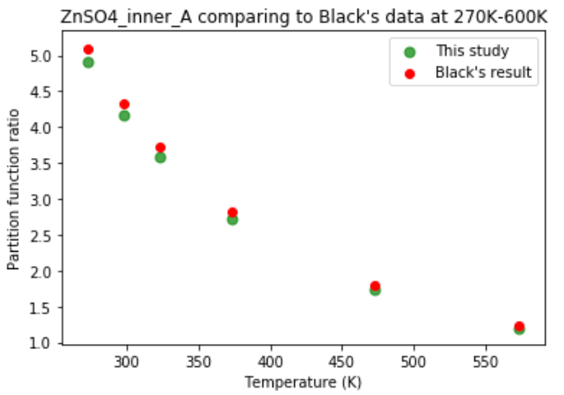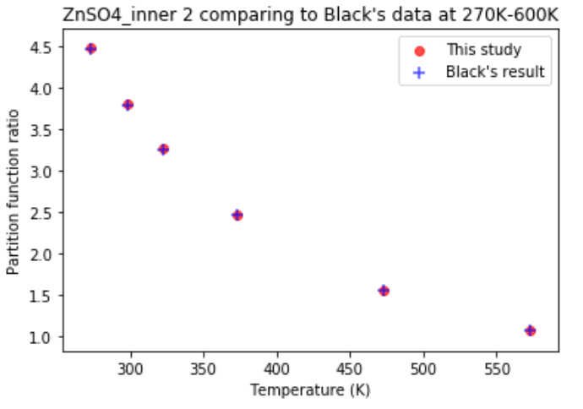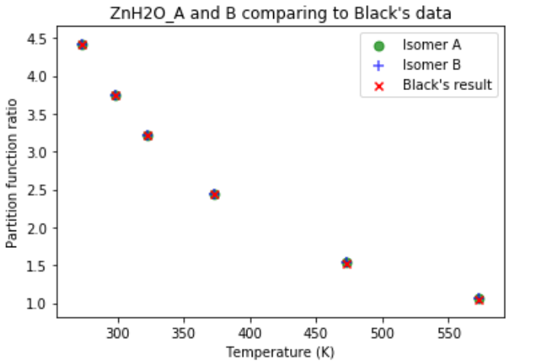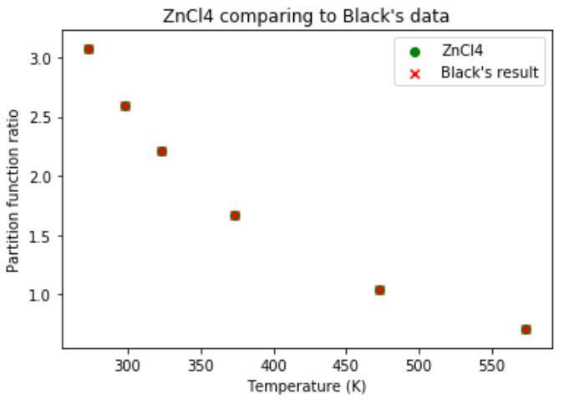

a)

c)

d)

b)

Figure 3a plots the 1000lnβ values of the six ZnSO4·4H2O isomers between 200-1200K and figure 3b plots the 1000lnβ values for isomer A and D. At the lowest temperature (200K, -73 ⁰C), the existence of different isomers have significant effects on the modelled vibrational frequencies of the molecule. This is reflected in the large absolute difference in the reduced partition function ratio between the isomer that was first proposed (isomer A) and the energetically most stable one (isomer D) at 200K. The complete table of the lnβ values of each isomers at different temperatures can be found in appendix B.

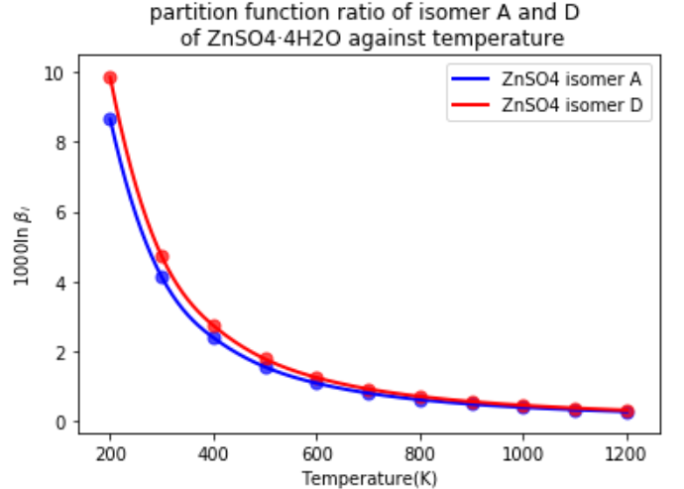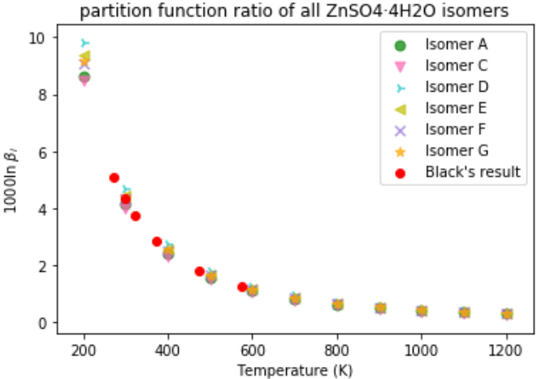

*Figure 3 (a,b) Partition function ratio of ZnSO4 isomers betweem 200K and 1200K.*

*a): All isomers*

*b): Isomer A and D. where isomer A is the octahedral structure proposed by Black (2015) and isomer D is the energetically most stable isomer found in this study.*

*a)*

*b)*

The variation in the absolute values of lnβ between different isomers decreases as temperature increases. After excluding the results for isomer B, the standard deviation in 1000lnβ of all isomers is ±0.45 at 200K and ±0.02 at 1200K. These numbers must be interpreted with caution because of the small absolute values of lnβ at high temperatures means that the relative variations in lnβ between different isomers is in fact higher at high temperature. Figure 4 plots the relative standard deviation (RSD) of lnβ at each temperature. As temperature increases, the RSD for lnβ rises from 4.19% to 6.75%. It is important to assess the significance of this difference on a case-by-case basis, for different molecules, reactions and isomers involved.

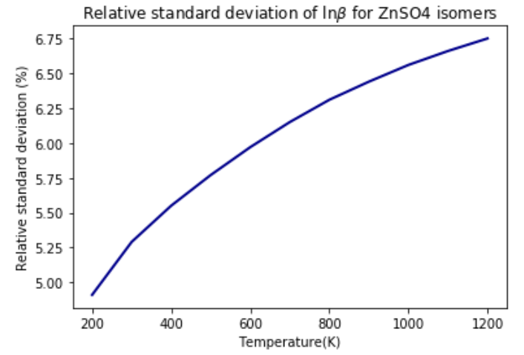

*Figure 4 The standard diviation of lnβ at each temperature for all isomers*

For the ZnSO4 isomers in this study, the % difference in lnβ for isomer A and D is 13.85% at 200K and increases to 15.36% at 1200K. The % difference in lnβ between ZnSO4·4H2O and ZnCl2 is between 30-31% and the % difference in lnβ between ZnSO4·4H2O and Zn(H2O)6 is as low as 13%, thus a % difference of up to 15% between isomers can potentially cause significant affect any calculations on isotope signature or isotopic fractionation.

What is interesting in these results is the lack in correlation between lnβ and other features of the isomers. Figure 5a and b plot the relationship between lnβ and a) bond length between central Zn and the S on sulphate ligand, b) ΔE of the isomer. No correlation have been seen between bond length and lnβ or between energy and lnβ.

These results would seem to suggest that when studying combustion products, the existence of different structural isomers can potentially cause significant effect on the result on frequency calculation of the molecule. Although it is possible for this effect to be small, there is currently no simple way to assess the magnitude of the effect without complete frequency calculation and comparison between individual isomers. It is important to be aware of the potential inaccuracy that can be introduced by the existence of multiple isomers, and it may be necessary to use the energetically most stable isomer, or a combination of multiple isomers when calculating the partition function ratio or the isotope signature of a species.

In later sections of this study, the result from both isomer A and D will be used in order to gain a better understanding of the magnitude of the effect of the existence of different structural isomers on isotope fractionation calculation.

*Figure 5 a): Plot of lnβ against bond length between central Zn atom and S atom on the Sulphate ligand. With*

*an autogenerated 1st order best fit line generated using the ‘polyfit’command in python*

*b): Plot of lnβ against ΔE of all isomers*

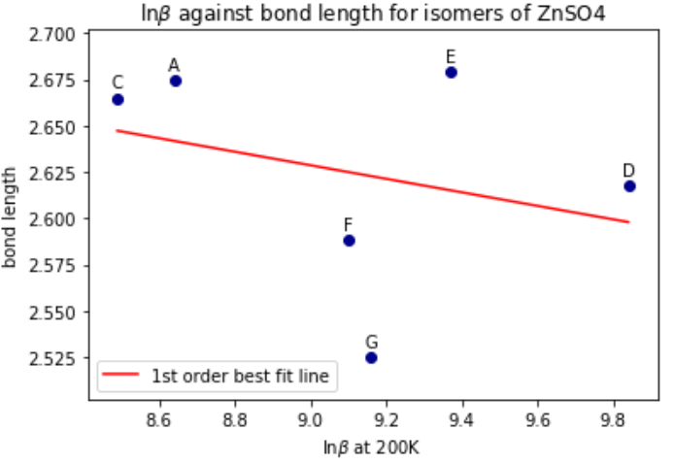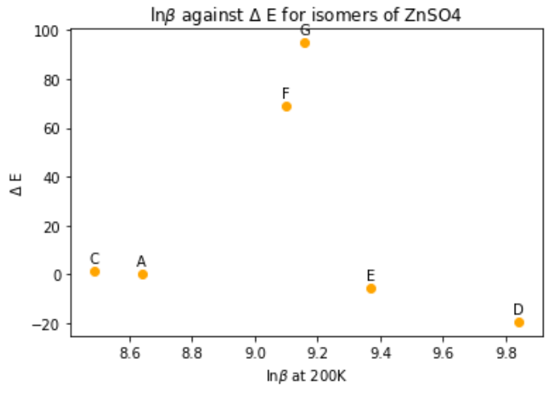

## **4.3.** Isotope signature calculation and environmental applications

In this chapter, a model of the dominating reaction of Zn after combustion will be created, this allows the isotope signature of each Zn species be calculated through isotope fractionation calculation with a given isotope signature of the combustion source.

### 4.3.1 Model for stable isotope fractionation of Zinc

The main stable species for Zn at high temperature are Zn(g) and ZnCl2(g). ZnCl2(g) preferentially forms between 600-1300K if HCl is present in the atmosphere and Zn(g) is the only Zn species present at above 1300K (Dı´az-Somoano and Martinez-Tarazona, 2002). Zn(g) in a single-atom molecule and thus does not experience isotope fractionation caused by molecule vibration. Therefore, ZnCl2(g) will be the only Zn species in the reactant in this model.

After leaving the furnace, at < 1200K, the presence of Sulphur will lead to the formation of ZnSO4 species by displacing the Cl atoms with Sulphate molecule until the temperature decreases to 900K (Cai et al., 2014). Cai et al. proposed the condensation reaction from ZnCl2(g)to ZnSO4(s) with Sulphur present:

ZnCl2(g) + SO2 +1/2O2 +H2O-> H2O+ZnSO4(s) + 2HCl.

The isotope fractionation between ZnCl2 and ZnSO4, , can be calculated using eq.4 from chapter 4.5. Figure 6 plots the values between 200-1200K, in units of ‰. For ZnSO4, values calculated from both isomer A and D are used. The Δ value between ZnCl2 and ZnSO4 is small and close to zero at high temperature and becomes more negative as the temperature decreases, to -2.0‰ to -3.5‰ at 200K. The gradient of change is relatively shallow above 400K and a lot steeper below 400K. This trend persists for both isomer A and D, although isomer D seems to give a more negative Δ value at all temperature.

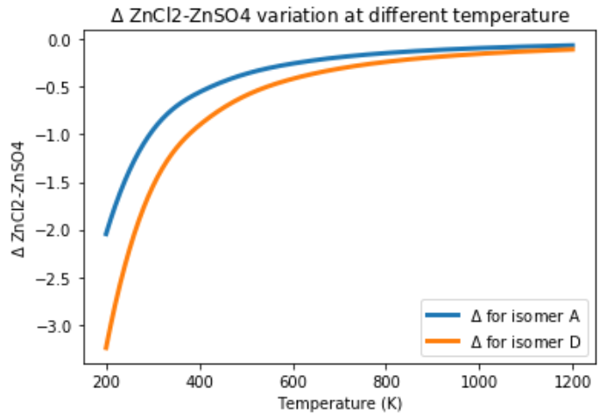

*Figure 6 calculated using isomer A (blue) and isomer D (orange), between 200K-1200K*

Between 900-1200K, in the temperature range where this reaction theoretically happens, varies from 0.07‰ to -1.12‰ for isomer A and varies from -1.07‰ to -1.19‰ for isomer D. Within this temperature range, the uncertainties introduced by different isomers is considerably higher than the variation in Δ itself. Therefore, for the purpose of studying combustion product, using the correct isomer(s) is crucial for getting any reliable result on the isotope fractionation between species.

### 4.3.2 The isotope signature of ZnCl2 and ZnSO4 in combustion product

In a simple model where we only consider the reaction:

ZnCl2(g) + SO2 +1/2O2 =H2O+ZnSO4(s) + 2HCl

We can calculate of the combustion product which then allows the calculation of the isotope signature of each individual species possible. In chapter 4.5, we related the isotope signature of the combustion source, β, and the isotope signature of Zn species through mass balance with the equation 4.

This equation allows us to predict for ZnCl2 and ZnSO4, provided with the of the combustion source. In this section, all calculations involving β for ZnSO4 are based on the electron structure calculation for isomer D (the energetically most stable isomer for ZnSO4) unless stated otherwise.

This is however a very simple model, and multiple assumptions and constrains must be applied to ensure the accuracy of any results. The primary assumption of this model is that ZnCl2 and ZnSO4 are most the abundant species and the reaction between the two species is the dominant reaction during the condensation of Zinc vapour. In reality, ZnAl2O4 and Zinc Silicates are also common condensation products from ZnCl2 the formation of these species is subject to the availability of other molecules in the combustion source. It is also assumed that the existence of sufficient Sulphur, Oxygen and HCl from coal to enable the formation of the key species as ZnCl2 will condense into ZnO without the presence of Sulphur and condense into ZnS in a reducing environment without sufficient Oxygen (Cai et al., 2014). It is worth noticing that in this reaction, ZnCl2 is a gas phase molecule whereas ZnSO4 is in solid phase. During electron structure calculation, both molecules have been modelled as gas phase molecules. Modelling ZnSO4 as a gaseous molecule does not alter its isotope signature as phase transition happens after equilibrium fractionation. However, this is only correct under the assumption that all ZnSO4(g) turn into ZnSO4(s) during the phase transition. Incomplete phase transition can lead to Kinetic fractionation where light isotopes preferentially stay in gas phase, causing alteration in the isotope ratio of the ZnSO4 species.

Gonzalez and Weiss (2015) has measured the δ66ZnIRMM in coal to be between +0.73 and +1.18‰. Using δ66Zn=1‰, combining with the model above, the isotopic signature of ZnSO4 and ZnCl2 can be predicted as shown on figure 7a and b. Note that the temperature range of this set of figures is 700K - 1500K, in order to ensure that the temperature in which this reaction theoretical occurs (900-1200K) is well included in any figures. No studies in this field have attempted to measure the ratio of different Zn (or other heavy metal) species in a combustion product such as fly ash or fuel gas, mainly due to technical difficulties. Therefore, a range of ratio of ZnCl2 and ZnSO4 have been used in figure 7.

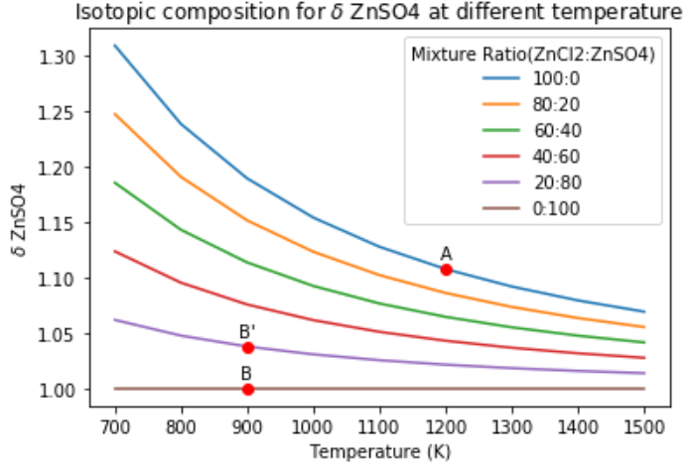

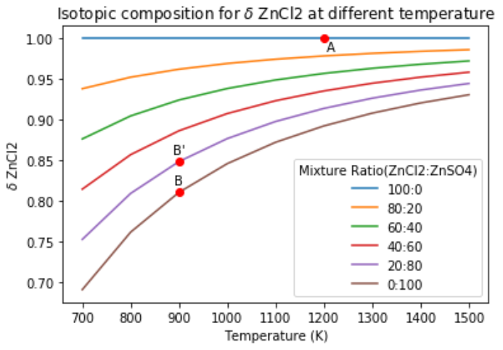

*Figure 7 (a-b): The isotope signature of a): ZnSO4 and b): ZnCl2 at varing temperature and composition. Point A indicates the likely isotope signature at 1200K for each species and point B and B’ indicates the likely isotope signature at 900K for the each species.*

Figure 7 a and b have shown clear and opposite trend in variation in isotopic composition between ZnSO4 and ZnCl2. ZnSO4 gets lighter as temperature increases whereas ZnCl2 gets heavier. It is clear that the increase in isotopic fractionation at decreasing temperature is caused by this opposite behaviour of the two species. As temperature changes, the ratio of the two species is expected to change, from 100% ZnCl2 at 1200K to almost 100% ZnSO4 at 900K. The isotope signature of each species is expected to be close to the value of point A (figure 7 a and b) at 1200K and point B at 900K when the reaction theoretically terminates. In reality, ZnCl2 does not fully react into ZnSO4 and δ is more likely to lay between B and B’. Therefore, for a coal sample with an isotope signature of δ66ZnIRMM = +1‰, the δ66Zn is expected to have a δvalue of between +1‰ and + 1.04‰ for ZnSO4 and between +0.81‰ and +0.85‰ for ZnCl2 in its combustion product.

If a sample measures to have a heavier δ66Zn, it is expected to contain mostly ZnSO4 and very little ZnCl2, which would be the expected value for the δ66Zn measured from polluted air or ash samples, as most ZnCl2 is expected to be turned into ZnSO4 during its condensation process. This agrees with the conclusion made by Gonzalez and Weiss (2015) which highlighted the heavy δ66ZnIRMM in gas vapour and fly ash particles. Martin et al. (2018) has also measured a heavy δ66Zn from plant samples in Zaragoza, Spain and suggested that this heavy isotope signature is closely associated with fly ash particles.

Gonzalez and Weiss (2015) has found a lighter isotope signature of the bottom ashes in the power plants, which does not reach vapour phase, ranging from +0.26‰ to +0.64‰. This is worth highlighting as this suggests that δ66Zn of the starting vapour after combustion is expected to be higher than δ66Znin un-combusted coal. There would therefore seem to be a definite need for further investigations on the isotope signature of the species that enters the condensation stage, in order to improve the accuracy in calculating the δ value for each species involved.

### 4.3.3 The effect of isomers on isotope signature calculations

δ66ZnSO4 has been calculated using β of isomer A in order to assess the effect of using different isomers on the isotope signature of the species. Figure 8 plots δ66ZnSO4 for both isomers assuming 50% of the species are ZnSO4. At 700K, the isotope signature for isomer A and D are +1.09‰ and +1.15‰ respectively and at 1500K, they are 1.02‰ and 1.03‰ respectively. Showing a variation between 0.01‰ to 0.06‰ in the modelled δ66ZnSO4 values. During high temperature processes, the isotope fractionation is typically large and is expected to be >0.1‰ and averaged at between 0.5‰ and 1‰ (Mattielli et al., 2009; Martin et al., 2018; Shiel et al. 2009). Taken together, these results suggest that although using different isomers have shown significant effect on the calculation result of isotope fractionation, it has not shown the same magnitude of effects on isotope signature calculations and failure in accounting for the effect of isomers is very unlikely to invalidate any calculation results. However, using different isomers have shown visible effect on δ66ZnSO4 calculations, therefore, it is always recommended, where possible, to account for the existence of isomers and use the energetically most stable isomer or a combination of multiple isomers while carrying out electron structure calculations for combustion products, in order to produce more accurate and reliable results.

*Figure 8: The isotope composition of ZnSO4 calculated using isomer A (blue) and isomer D (yellow)*

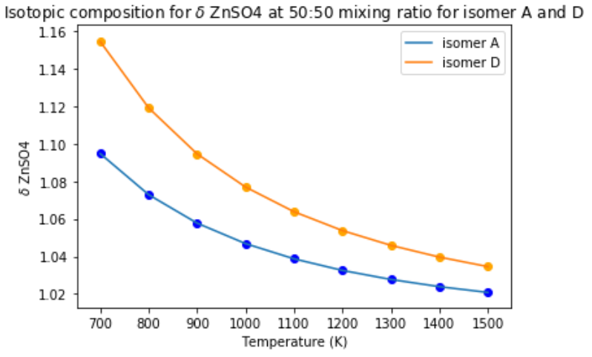

# Conclusion and future study

The reduced partition function ratio of Zinc species has been determined using electron structure calculation with the density function theory and the results have shown excellent consistency with past results.

No previous studies have account for the effect of structural isomers on partition function ratio and isotope fractionation calculation. However, the use of different structural isomers have proven to be an important factor that can alter the partition function ratio of a structure by 15%, which is similar to the difference in partition function ratio between different Zinc species. Although this variation does not seem to show the same scale of effect on isotope signature calculation and is not expected to cause significant errors or inaccuracy when calculating high temperature stable isotope fractionation of Zinc species, due to the limit sample size in this study, caution must be applied, and where possible, it is always recommended to consider different structural isomers while carrying out electron structure calculations.

No relationships has been found for β between its magnitude and the zero-point energy of the isomers or the bond length between central Zn atom and the SO4 ligand. Therefore, there is currently no way to predict the magnitude of effect for having different isomers without manually carrying our energy calculation for each of the possible isomers.

With the assumption that the dominant reaction of Zn during condensation after leaving the furnace is between only two species, ZnCl2 and ZnSO4, a model can be created to predict the isotope signature of the species giving the isotope signature of Zn in coal or other combustion sources. It is expected that after combustion, most Zinc will be converted into ZnCl2(g) with the presence of HCl from coal or waste, then as temperature decreases, ZnSO4(s) will start to form by displacing the Chlorine in ZnCl2 species and condense into solid particles. ZnSO4 have shown heavier isotope signature than ZnCl2, therefore, a fly ash sample with a heavier isotope signature is expected to contain primarily ZnSO4 species.

# References

Araújo, D.F., Machado, W., Weiss, D., Mulholland, D.S., Garnier, J., Souto-Oliveira, C.E. and Babinski, M., 2018. Zinc isotopes as tracers of anthropogenic sources and biogeochemical processes in contaminated mangroves. Applied Geochemistry, 95, pp.25-32.

Black, J., Kavner, A. and Schauble, E., 2010. Calculation of equilibrium stable isotope partition function ratios for aqueous zinc complexes and metallic zinc. Geochimica et Cosmochimica Acta, 75(3), pp.769-783.

Blanchard, M., Balan, E. and Schauble, E., 2017. Equilibrium Fractionation of Non-traditional Isotopes: a Molecular Modeling Perspective. *Reviews in Mineralogy and Geochemistry*, 82(1), pp.27-63.

Briffa, J., Sinagra, E. and Blundell, R., 2020. Heavy metal pollution in the environment and their toxicological effects on humans. Heliyon, 6(9), p.e04691.

Cai, X., Huang, Q., Alhadj-Mallah, M., Chi, Y. and Yan, J., 2015. Characterization of zinc vapor condensation in fly ash particles using synchrotron X-ray absorption spectroscopy. *Journal of Zhejiang University-SCIENCE A*, 16(1), pp.70-80.

Cccbdb.nist.gov. 2020. CCCBDB Listing Of Experimental Data. [online] Available at: <https://cccbdb.nist.gov/exp2x.asp?casno=7664939&charge=0> [Accessed 28 December 2020].

Desaulty, A. and Petelet-Giraud, E., 2020. Zinc isotope composition as a tool for tracing sources and fate of metal contaminants in rivers. Science of The Total Environment, 728, p.138599.

Dı́az-Somoano, M. and Martı́nez-Tarazona, M., 2003. Trace element evaporation during coal gasification based on a thermodynamic equilibrium calculation approach. Fuel, 82(2), pp.137-145.

Frandsen, F., Dam-Johansen, K. and Rasmussen, P., 1994. Trace elements from combustion and gasification of coal—an equilibrium approach. Progress in energy and combustion science, 20(2), pp.115-138.

Fujii, T., Moynier, F., Telouk, P. and Abe, M., 2010. Experimental and theoretical investigation of isotope fractionation of zinc between aqua, chloro, and macrocyclic complexes. the Journal of Physical Chemistry A, 114(7), pp.2543-2552.

Hargittai, M., 1988. The molecular geometry of gas-phase metal halides. Coordination chemistry reviews, 91, pp.35-88.

Hennings, E., Schmidt, H. and Voigt, W., 2014. Crystal structures of ZnCl2·2.5H2O, ZnCl2·3H2O and ZnCl2·4.5H2O. Acta Crystallographica Section E Structure Reports Online, 70(12), pp.515-518.

Huntresearchgroup.org.uk. 2021. Hunt Theoretical Chemistry Group Researching Ionic Liquids Photochemistry And Catalysis, Imperial College London. [online] Available at: <http://www.huntresearchgroup.org.uk/> [Accessed 3 January 2021].

Maréchal, C.N., Télouk, P. and Albarède, F., 1999. Precise analysis of copper and zinc isotopic compositions by plasma-source mass spectrometry. Chemical geology, 156(1-4), pp.251-273.

Martín, A., Caldelas, C., Weiss, D., Aranjuelo, I. and Navarro, E., 2018. Assessment of metal immission in urban environments using elemental concentrations and Zinc isotope signatures in leaves of Nerium oleander. Environmental science & technology, 52(4), pp.2071-2080.

Mattielli, N.; Petit, J. C. J.; Deboudt, K.; Flament, P.; Perdrix, E.; Taillez, A.; Rimetz-Planchon, J.; Weis, D. Zn isotope study of atmospheric emissions and dry depositions within a 5 km radius of a Pb−Zn refinery. Atmos. Environ. 2009, 43 (6), 1265−1272.

Merian, E., 1980. Toxicity of heavy metals in the environment. Chemosphere, 9(2), pp.N8-N9.

Moeller, K., Schoenberg, R., Pedersen, R.B., Weiss, D. and Dong, S., 2012. Calibration of the new certified reference materials ERM‐AE633 and ERM‐AE647 for copper and IRMM‐3702 for zinc isotope amount ratio determinations. Geostandards and Geoanalytical Research, 36(2), pp.177-199.

Ochoa Gonzalez, R. and Weiss, D., 2015. Zinc Isotope Variability in Three Coal-Fired Power Plants: A Predictive Model for Determining Isotopic Fractionation during Combustion. Environmental Science & Technology, 49(20), pp.12560-12567.

Qu, C., Ma, Z., Yang, J., Liu, Y., Bi, J. and Huang, L., 2012. Human Exposure Pathways of Heavy Metals in a Lead-Zinc Mining Area, Jiangsu Province, China. PLoS ONE, 7(11), p.e46793.

Querol, X., Fernández-Turiel, J. and López-Soler, A., 1995. Trace elements in coal and their behaviour during combustion in a large power station. Fuel, 74(3), pp.331-343.

Shiel, A.E., Weis, D. and Orians, K.J., 2010. Evaluation of zinc, cadmium and lead isotope fractionation during smelting and refining. Science of the total environment, 408(11), pp.2357-2368.

Wang, X., Sato, T., Xing, B. and Tao, S., 2005. Health risks of heavy metals to the general public in Tianjin, China via consumption of vegetables and fish. Science of The Total Environment, 350(1-3), pp.28-37.

# Appendix

## Appendix A

Table A: The 2D geometry of all ZnSO4·4H2O isomers

|  |  |  |
| --- | --- | --- |
| Structure | Code | Structure |
| ZnSO4·4H2O | A |  |
|  | B |  |
|  | C |  |
|  | D |  |
|  | E |  |
|  | F |  |
| s | G |  |

## Appendix B

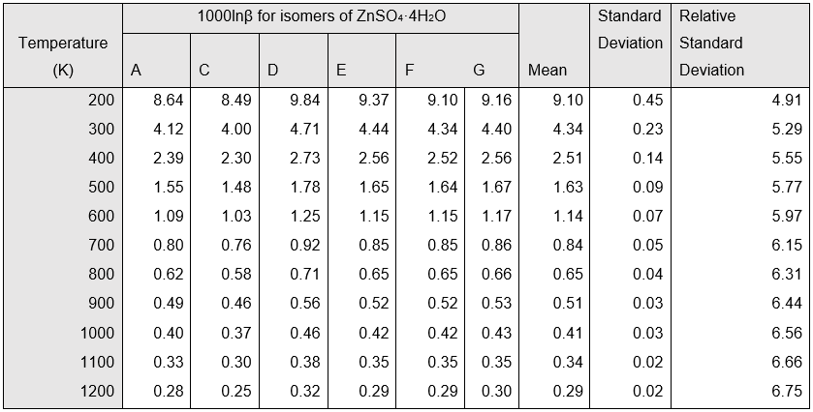

Table A The reduced partition function ratio of all ZnSO4 isomers at different temperature, their mean, standard deviation, and relative standard deviation (RSD)